**MICROSOFT AZURE FUNDAMENTALS CLOUD COMPUTING**

**COURSE OVERVIEW**

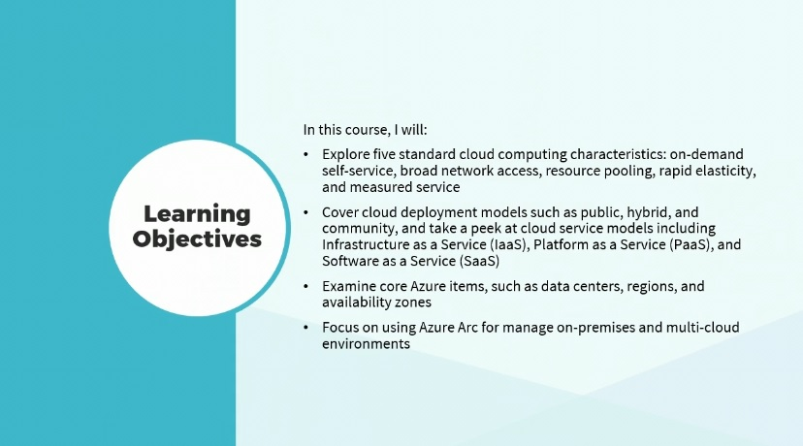

Hi there, I'm Dan Lachance.

The popularity of cloud computing has exploded in recent years.

Organizations can streamline IT service efficiency with the use of cloud services in the Microsoft Azure environment.

In this course, I’ll explore five standard cloud computing characteristics:

on-demand,

self-service,

broad network access,

resource pooling,

rapid elasticity, and measured service.

I will cover cloud deployment models such as public, hybrid, and community, and take a peek at cloud service models including Infrastructure as a Service or IaaS, Platform as a Service(PaaS), and Software as a Service (SaaS).

I will examine core Azure items, such as data centers, regions, and availability zones.

Finally, I will focus on using Azure Arc for managing on-premises and multi-cloud environments. This course can be used to prepare for exam AZ-900, Microsoft Azure Fundamentals.

**CLOUD COMPUTING CHARACTERISTICS**

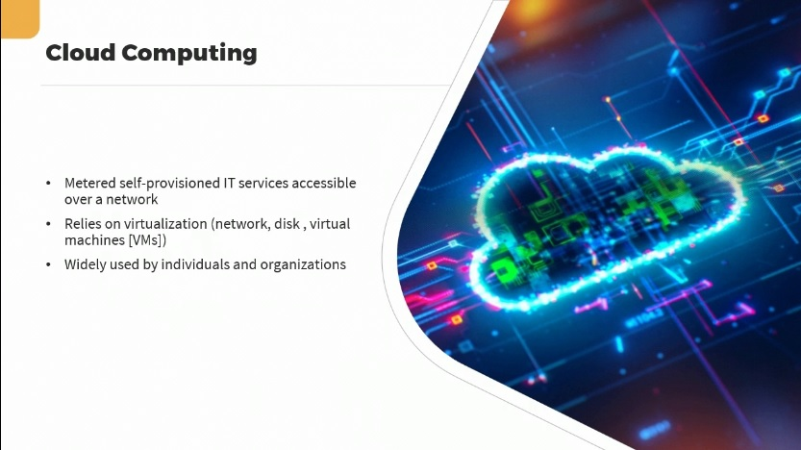

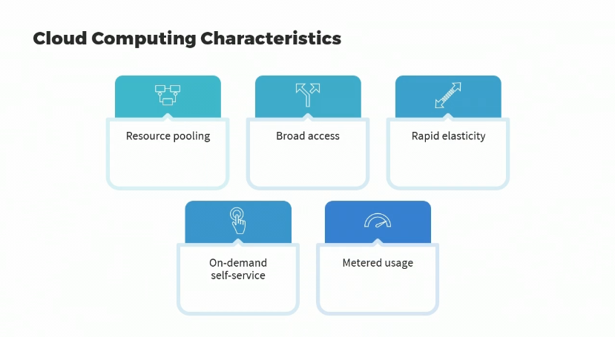

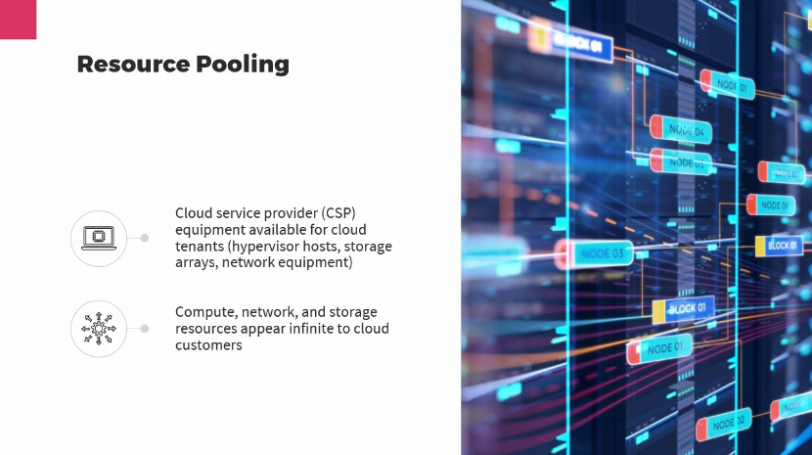

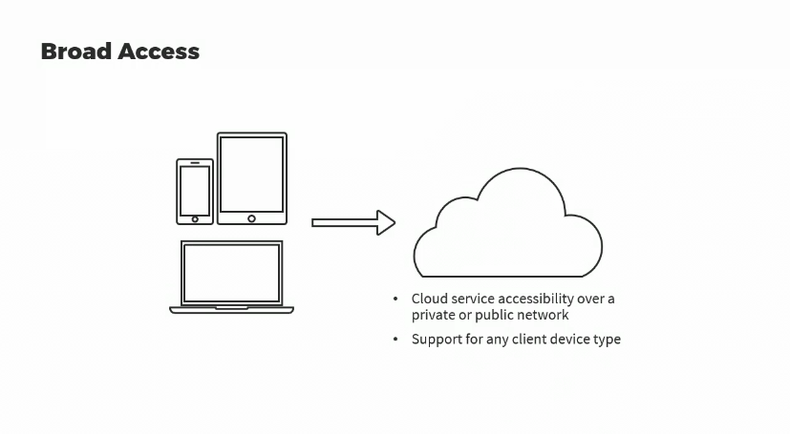

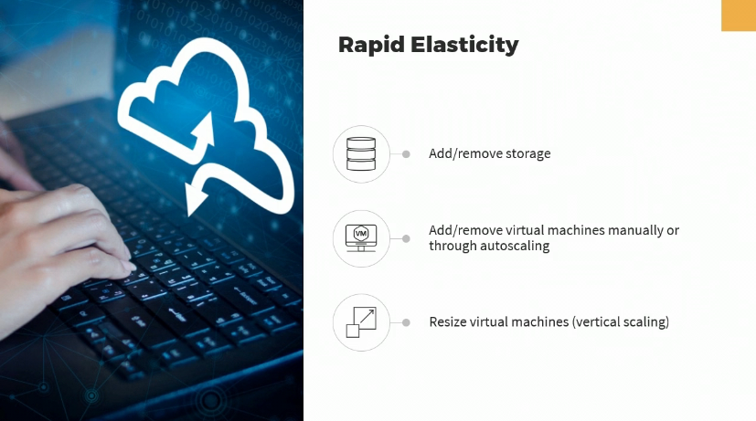

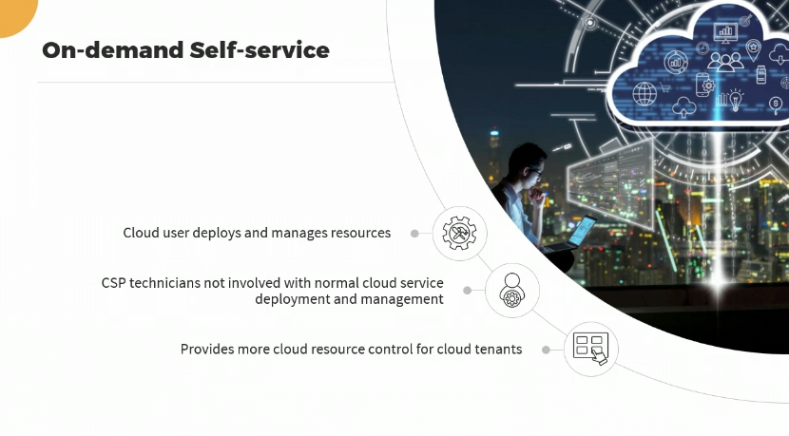

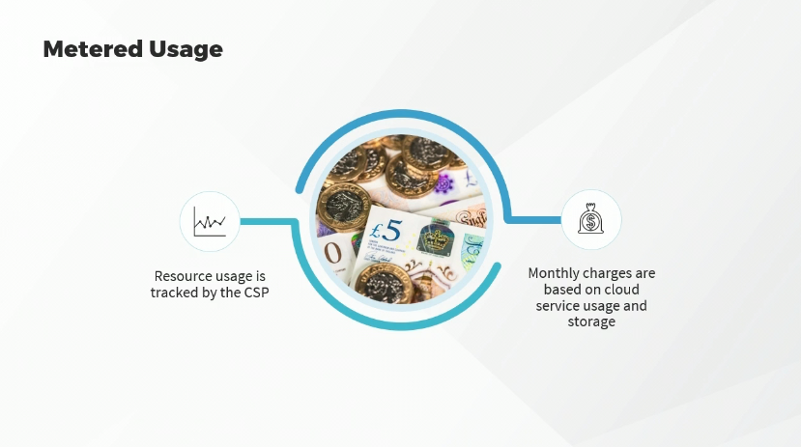

**VIRTUALIZATION AND THE MICROSOFT AZURE CLOUD**

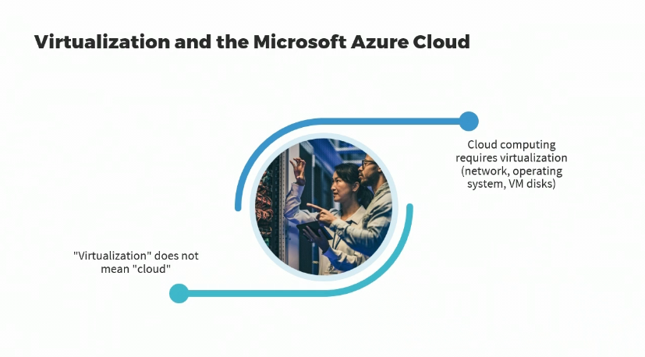

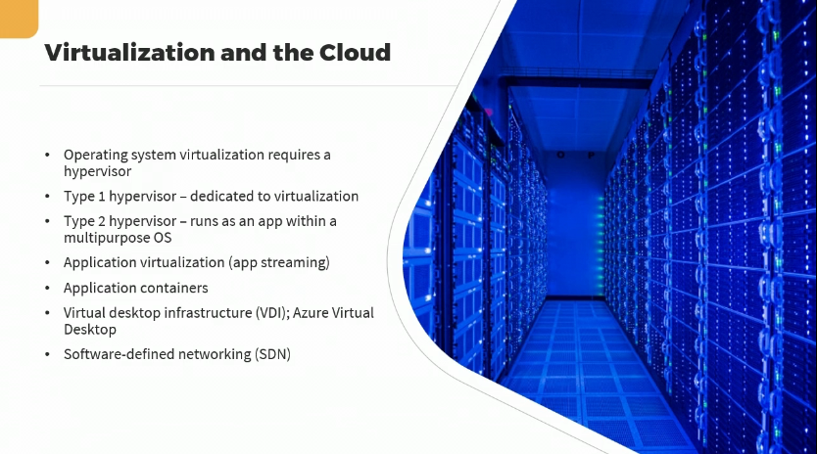

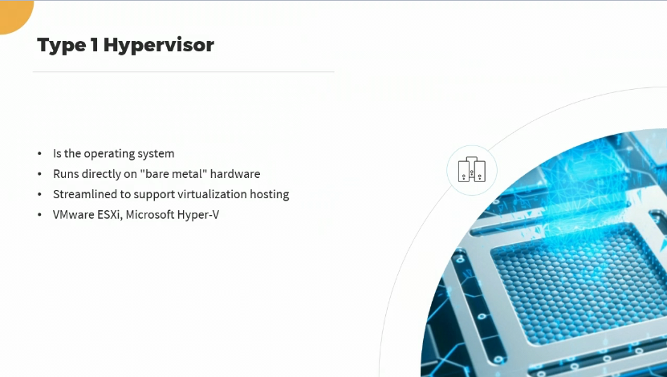

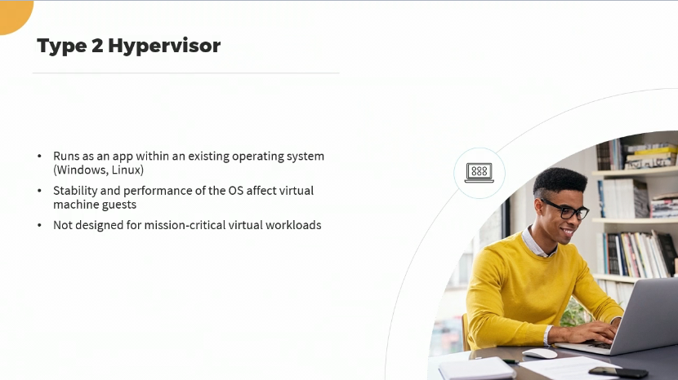

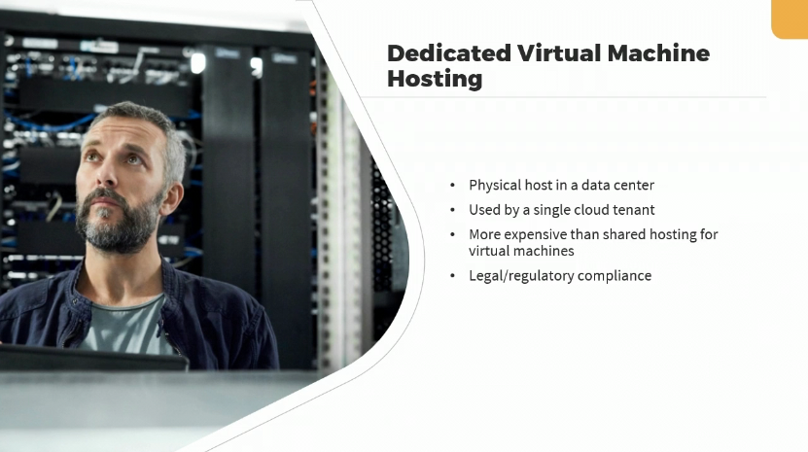

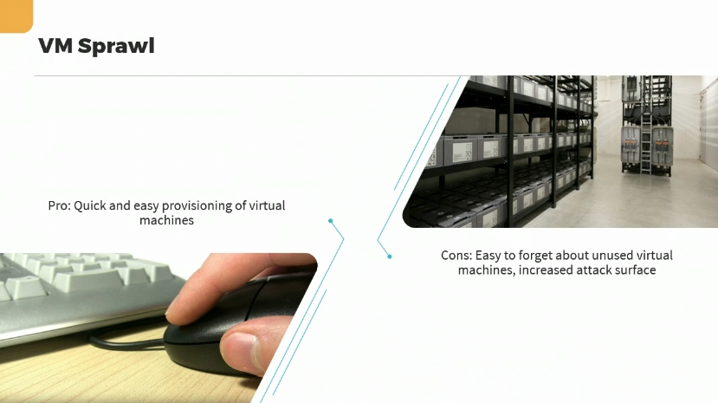

**CLOUD DEPLOYMENT MODELS**

